Software Requirement Specification

**Document History**

|  |  |  |  |  |  |  |
| --- | --- | --- | --- | --- | --- | --- |
| **Document Name** | **Version** | **Status** | **Date** | **Viewable** | **Reviewer** | **Responsible** |
| iWish - SRS V.[1.0].docx | **Add**   * Introduction * URSA * URSW * SRSA * SRSW * Use Case Diagram * Use Case Description | Draft | 20-05-2015 | VC, SK, KS | VC, SK | VC, SK |
| iWish - SRS V.[1.0].docx | **Edit**   * Introduction * URSA * URSW * SRSA * SRSW * Use Case Diagram(Web) * Use Case Description (Web) * Use Case Diagram(Android) * Use Case Description (Android) | Release | 22-07-2015 | VC, SK, KS | VC, SK | VC, SK |
| iWish - SRS V.[1.5].docx | **Edit**   * Introduction * URSA * URSW * SRSA * SRSW * Use Case Diagram(Web) * Use Case Description (Web) * Use Case Diagram(Android) * Use Case Description (Android) | Release | 23-08-2015 | VC, SK, KS | VC, SK | VC, SK |
| iWish - SRS V.[2.0].docx | **Add**   * URSA * URSW * SRSA * SRSW * Use Case Diagram(Web) * Use Case Diagram(Android) * Use Case Description (Android) | Draft | 02-10-2015 | VC, SK, KS | VC, SK | VC, SK |
| iWish - SRS V.[2.0].docx | **Edit**   * Description (Android) | Release | 21-10-2015 | VC, SK, KS | VC, SK | VC, SK |

**\*VC = Visava Chumnuam**

**\*SK = Saksorn Khongsirirat**

**\*KS = Kittitouch Suteeca**

**Table of Contents**

1. Introduction 5

1.1 Project Overview 5

1.1.1 Purpose 5

1.1.2 Scope 5

1.1.3 Acronyms …………………………………………………………………………………………....5

1.1.4 User Characteristic…………………………………………………………………………………...5

2. URS 5

3. SRS. 7

4. Use Case Diagram Web 9

4.1 Use Case Description Web 9

5. Use Case Diagram Android 19

5.1 Use Case Description Android 20

# **Introduction**

**1.1 Purpose**

The purpose of software specification is gathering the requirements of the iWish’s software. The document will contain about what are the software should be.

**1.2 Scope**

The application will be developed by Android Studio.

- Focus on only one supermarket.

- Provide system management products in the database.

- Provide the Android application for manage wish list.

- Convenient features for Android application site.

* 1. **Acronyms**

**Acronyms**

ADA Activity Diagram Android

ADW Activity Diagram Web Application

APK Android Package Kit

SDA Sequence Diagram Android

SDW Sequence Diagram Web Application

SK Saksorn Khongsirirat

SRS System Requirement Specification

UCA Use case Diagram Android

UCW Use case Diagram Website

URSA User Requirement Specification Android

URSW User Requirement Specification Website

VC Visava Chumnuam

* 1. **User Characteristic**
     1. **Admin =** the staff of a supermarket which can manage the products in the database and provide information about each product and NFC tag on the shelves.
     2. **Customer** = the people that are a customer of the supermarket and use iWish application.

1. **User Requirements**

- **URSW-01**: Admin can login to the web application.

- **URSW-02**: Admin can add a new product to the system.

- **URSW-03**: Admin can view all products in the system.

- **URSW-04**: Admin can search product by product’s ID in the system.

- **URSW-05**: Admin can edit product’s information.

- **URSW-06**: Admin can delete the product from the system.

- **URSW-07**: Admin can log out from the web application.

- **URSA-08**: The customer can view the shopping cart that show a detail of the product that add by the customer in list format.

- **URSA-09**: The customer can add the new product to the shopping cart by input ID of the product manually or using scanning barcode an amount of the product.

- **URSA-10**: The customer can edit the amount.

- **URSA-11**: The customer can delete the product.

- **URSA-12**: The customer can view the wish list page that show the detail (checkbox, name, amount, total price) of product that add by the customer in list format.

- **URSA-13**: The customer can add a new product to the wish list by select from the product list.

**- URSA-14**: The customer can view the detail (name, net weight, price, and promotion) of each product by click on the product.

1. **Software Requirements Specification**
   * **SRSW-01:** System shall provide login interface to receive ID and password.
   * **SRSW-02:** System shall validate input in a login form.
   * **SRSW-03:** System shall provide all products interface to allow admin to see all products in the system.
   * **SRSW-04:** System shall show a message “ID and password are incorrect”, if ID, password or both is wrong.
   * **SRSW-05:** System shall provide menu bar to allow admin to change the interface between “add product” and “all products”.
   * **SRSW-06:** System shall provide add product interface to receive ID, name, description, categorize, net weight and price.
   * **SRSW-07:** System shall verify product’s ID with existing product in the database.
   * **SRSW-08:** System shall record product’s information such as name, description, category, net weight, price, an amount required for promotion and promotion price in the database.
   * **SRSW-09:** System shall show a message “Add Success”.
   * **SRSW-10:** System shall provide a search interface to receive product’s ID.
   * **SRSW-11:** System shall retrieve and show products with similar or same as input in a search form.
   * **SRSW-12:** System shall provide edit button in each product for edit product’s information such as name, description, category, net weight, price, an amount required for promotion and promotion price.
   * **SRSW-13:** System shall provide edit product interface with product’s information in a form to receive new product’s information such as name, description, category, net weight, price, an amount required for promotion and promotion price or add amount require for promotion and promotion price except ID.
   * **SRSW-14:** System shall update product’s information such as name, description, category, net weight, price, an amount required for promotion and promotion price in the database.
   * **SRSW-15:** System shall show a message “Edit Success”.
   * **SRSW-16:** System shall provide delete button on each product for delete product’s information.
   * **SRSW-17:** System shall ask the admin for confirming to delete the product.
   * **SRSW-18:** System shall delete the product from the database.
   * **SRSW-19:** System shall show a message “Delete Success”.
   * **SRSW-20:** System shall provide a log out button for logout from the web application.
   * **SRSW-21:** System shall query and sent product’s information such as id, name, description, category, net weight, price, an amount required for promotion and promotion price in the database to the client by product’ id.

- **SRSW-22**: System shall query and sent all product’s information such as id, name, description, category, net weight, price, an amount required for promotion and promotion price in the database to the client.

- **SRSA-23**: The system shall display list that contain a name, amount of product that added by the customer and total price.

- **SRSA-24**: The system shall provide ADD button for adding a new product to the list.

- **SRSA-25**: The system shall ask method to add a product to shopping cart.

- **SRSA-26**: The system shall add a product by inputted product’ ID.

- **SRSA-27**: The system shall add a product by scanning a barcode of the product.

- **SRSA-28**: The system shall add a product by scanning NFC of the product.

- **SRSA-29**: The system shall provide a text box for editing amount of product on the list.

- **SRSA-30**: The system shall provide Delete button for deleting each product in the list.

- **SRSA-31**: The system shall display wish list page that contain a checkbox for each product, name, amount of each product and total price.

- **SRSA-32**: The system shall calculate the total price by calculating price and promotion with an amount of product in the list.

- **SRSA-33**: The system shall verify products in wish list with products in shopping cart.

- **SRSA-34**: The system shall display all product in the system from a database when the customer clicks on Add button for adding product on the wish list.

- **SRSA-35**: The system shall provide a dialog that contain an ID, name, description, categorize, net weight, price, an amount required for promotion and promotion of the product when the user click on the product.

1. **Use Case Diagram (Web Application)**

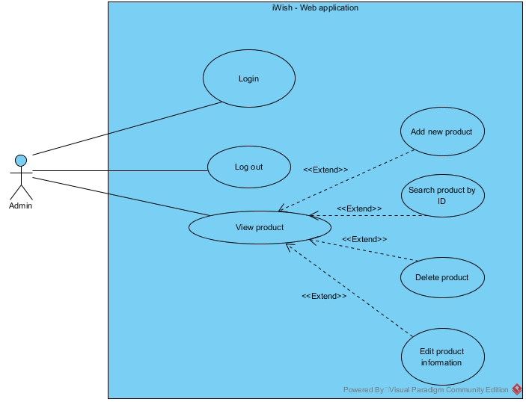

**Figure 7: Use Case Diagram Web Application**

**Use Case Description (Web Application)**

|  |  |
| --- | --- |
| Use Case ID: | UCW-01 |
| Use Case Name : | Login. |
| Short Description : | Admin can login to the web application to use other feature of a web application. |
| Actor: | Admin. |
| Pre-Conditions: | The supermarket must provide ID and password. |
| Post-Conditions: | Admin can manage products in the system. |
| Flow Of Events: | 1. The admin enters the web application. 2. The system shall direct “Login” page. 3. The admin input ID and password into a text box, then select “Login”. 4. The system shall validate ID and password. 5. The system shall redirect to “all product” page. |
| Alternative Flow: | From 4., If ID and password are invalid,  5a. The system shall show a message “ID and password are incorrect.” |
| Exception: | - |
| Priority: | High |

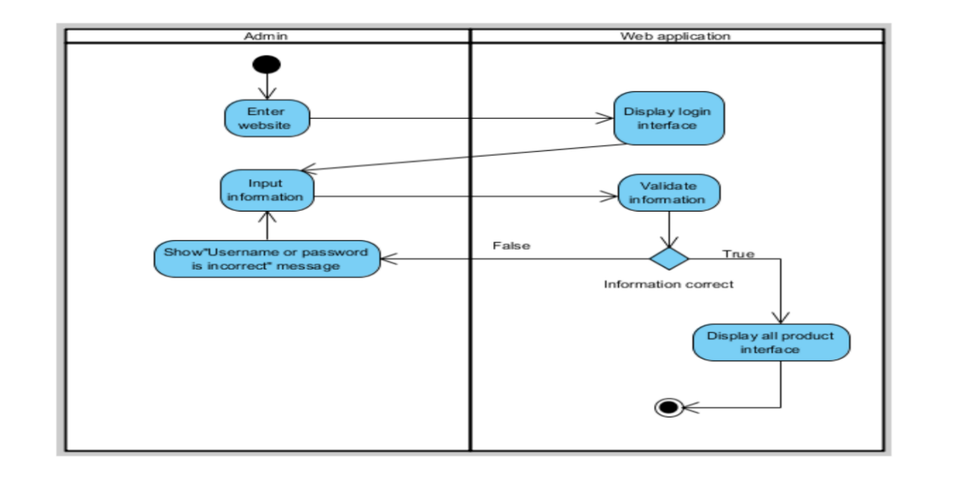

**Figure 8: ADW-01 Login**

|  |  |
| --- | --- |
| Use Case ID: | UCW-02 |
| Use Case Name : | Add new product. |
| Short Description : | Admin can add new a product that doesn’t exist in the system. |
| Actor: | Admin. |
| Pre-Conditions: | Login. |
| Post-Conditions: | - |
| Flow Of Events: | 1. The admin select “Add Product” on a menu bar. 2. The system shall redirect to “add product” page. 3. The admin input all information of the product into each text box except promotion part, then select “Add”. 4. The system shall verify product by ID. 5. The system shall create the product in the database. 6. The system shall redirect to “all product” page. 7. The system shall show a message “Add Success”. |
| Alternative Flow: | From 4., If the product already exists in the system,  5a. The system shall redirect to “all product” page. |
| Exception: | - |
| Priority: | High |

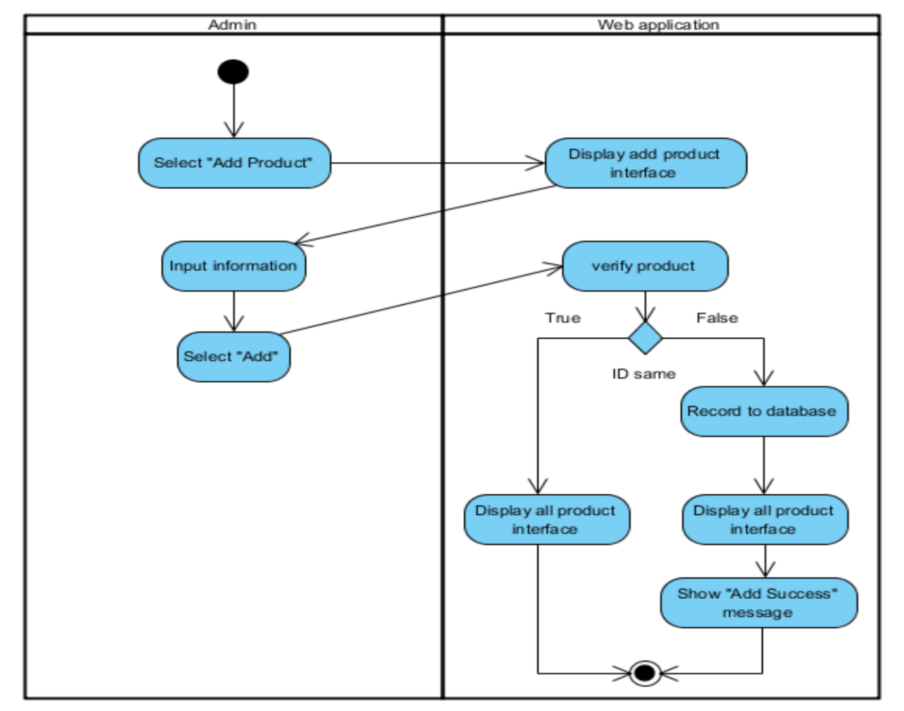

**Figure 9: ADW-02 Add New Product**

|  |  |
| --- | --- |
| Use Case ID: | UCW-03 |
| Use Case Name : | View products. |
| Short Description : | Admin can see all products with detailed that already exist in the system. |
| Actor: | Admin. |
| Pre-Conditions: | Login. |
| Post-Conditions: | - |
| Flow Of Events: | 1. The Admin select "All Product" from a menu bar. 2. The system shall redirect to “all products” page. |
| Alternative Flow: | - |
| Exception: | - |
| Priority: | Medium |

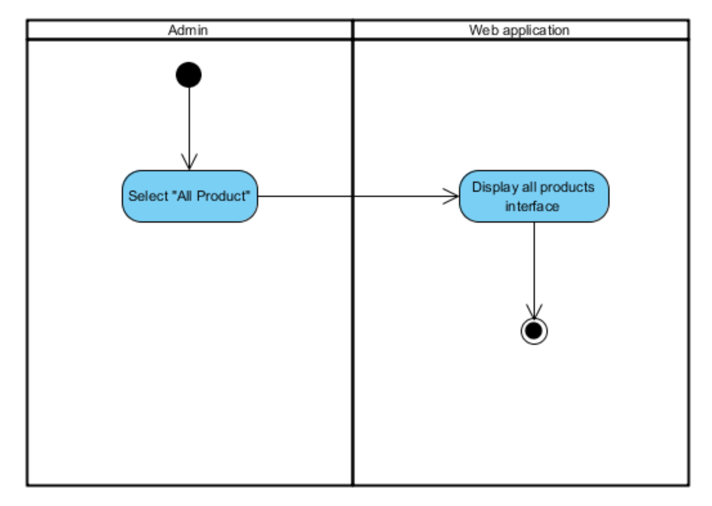

**Figure 10: ADW-03 View Product**

|  |  |
| --- | --- |
| Use Case ID: | UCW-04 |
| Use Case Name : | Search product by ID. |
| Short Description : | Admin can search for products that already exist in the system by product’s id to edit, delete or see the information. |
| Actor: | Admin. |
| Pre-Conditions: | View products. |
| Post-Conditions: | - |
| Flow Of Events: | 1. The admin input product’s id into a search box and selects “search”. 2. The system shall show products with same or similar to product’s id that admin inputted. |
| Alternative Flow: | - |
| Exception: | - |
| Priority: | Medium |

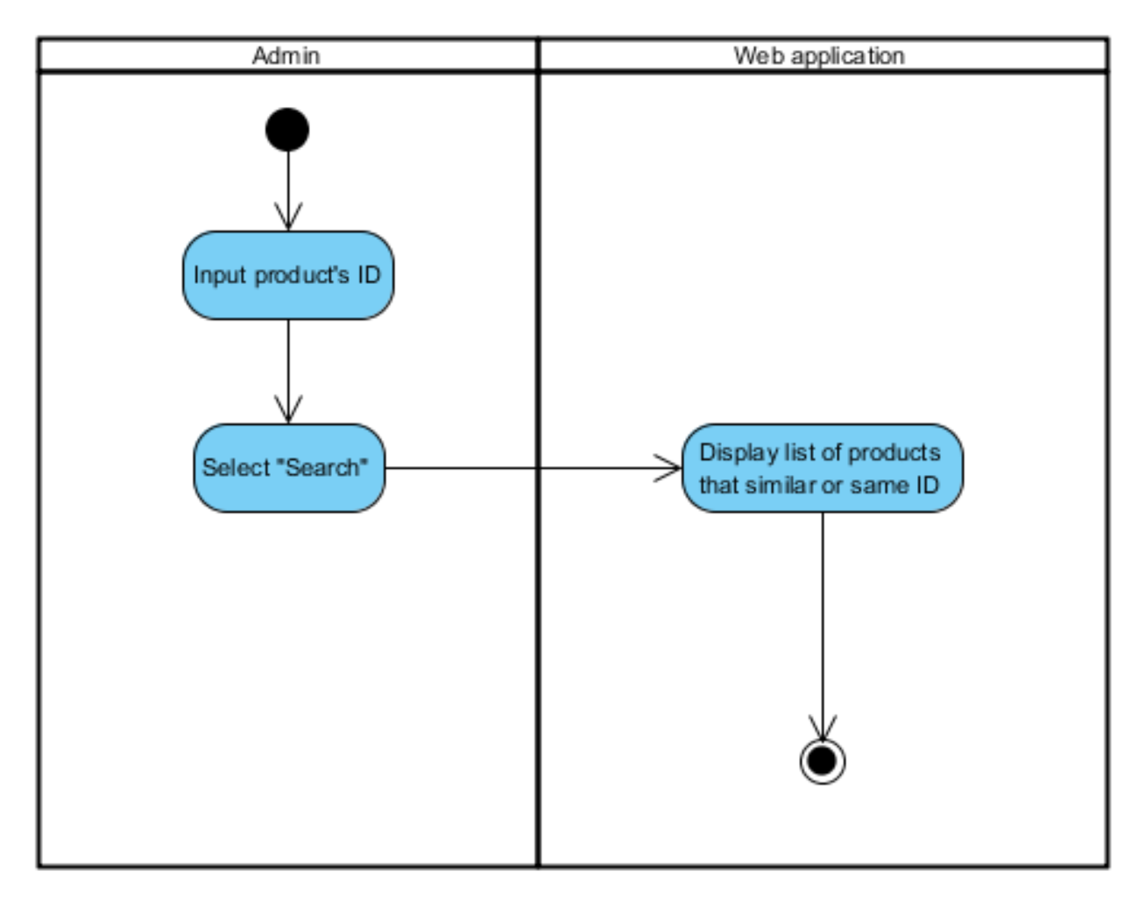

**Figure 11: ADW-04 Search Product by ID**

|  |  |
| --- | --- |
| Use Case ID: | UCW-05 |
| Use Case Name : | Edit product’s information. |
| Short Description : | Admin can edit the information of the product that already exists in the system. |
| Actor: | Admin. |
| Pre-Conditions: | View products. |
| Post-Conditions: | - |
| Flow Of Events: | 1. The admin select “Edit” in a row of product that admin want to edit. 2. The system shall retrieve the information of the product and redirect to “Edit” page. 3. The admin edit information that in a text box of each information and then select “Edit”. 4. The system shall update the information of the product in the database. 5. The system shall redirect to “all product” page. 6. The system shall show a message “Edit Success.” |
| Alternative Flow: | - |
| Exception: | - |
| Priority: | High |

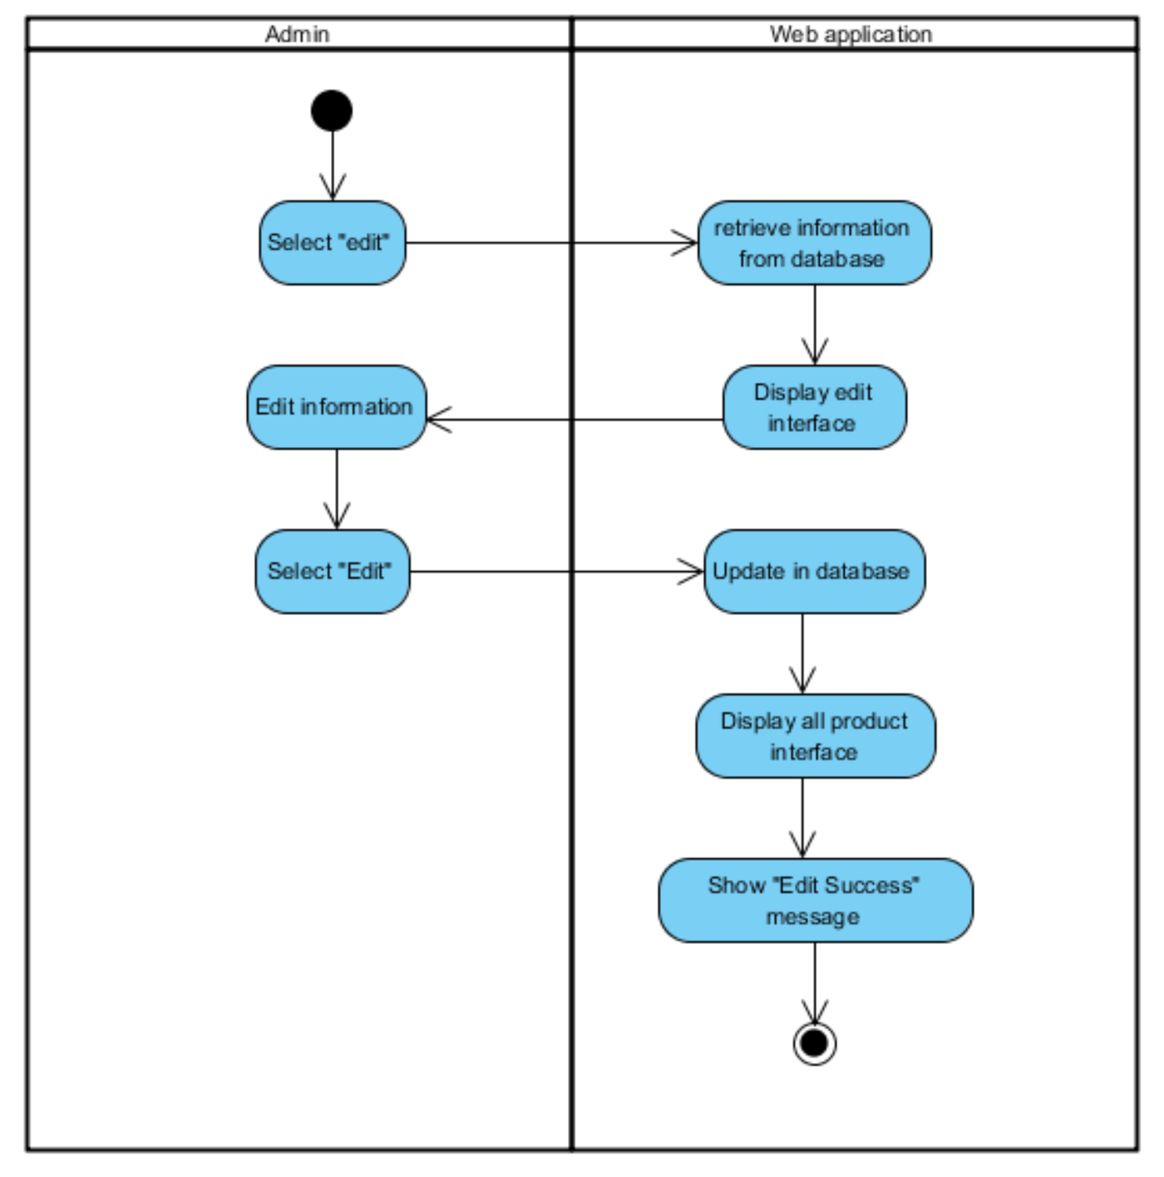

**Figure 12: ADW-05 Edit Product’s Information**

|  |  |
| --- | --- |
| Use Case ID: | UCW-06 |
| Use Case Name : | Delete product. |
| Short Description : | Admin can delete the product that already exists in the system and doesn’t sell anymore to prevent too much record in the database. |
| Actor: | Admin. |
| Pre-Conditions: | View products. |
| Post-Conditions: | - |
| Flow Of Events: | 1. The admin select “delete” in a row of product that admin want to delete. 2. The system shall ask for confirming. 3. The admin select “OK”. 4. The system shall delete the product from the database. 5. The system shall show a message “Delete Success”. |
| Alternative Flow: | From 2., If the admin selects “cancel”,  3a. Nothing happen. |
| Exception: | - |
| Priority: | Medium |

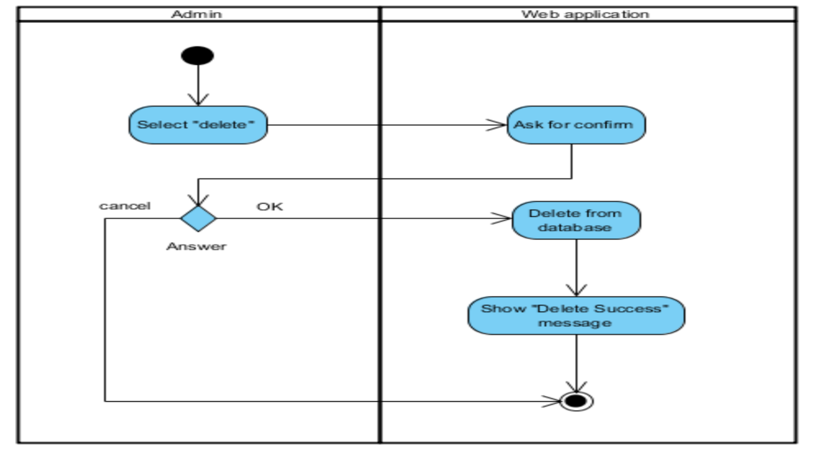

**Figure 13: ADW-06 Delete Product**

|  |  |
| --- | --- |
| Use Case ID: | UCW-07 |
| Use Case Name : | Log out. |
| Short Description : | Admin can log out from the web application for security. |
| Actor: | Admin. |
| Pre-Conditions: | Login. |
| Post-Conditions: | - |
| Flow Of Events: | 1. The admin select "log out". 2. The system redirects to “log in” page. |
| Alternative Flow: | - |
| Exception: | - |
| Priority: | Low |

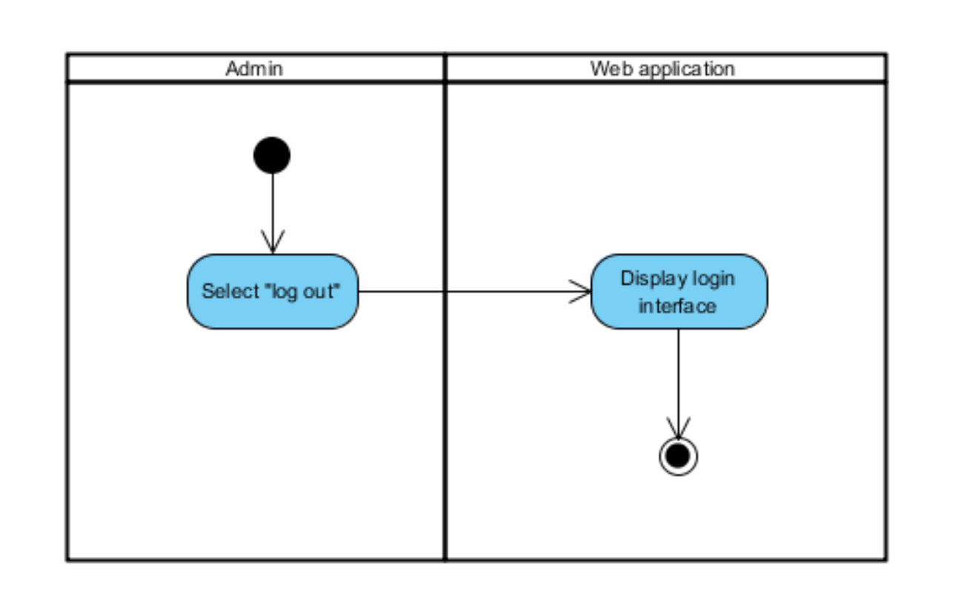

**Figure 14: ADW-07 Log out**

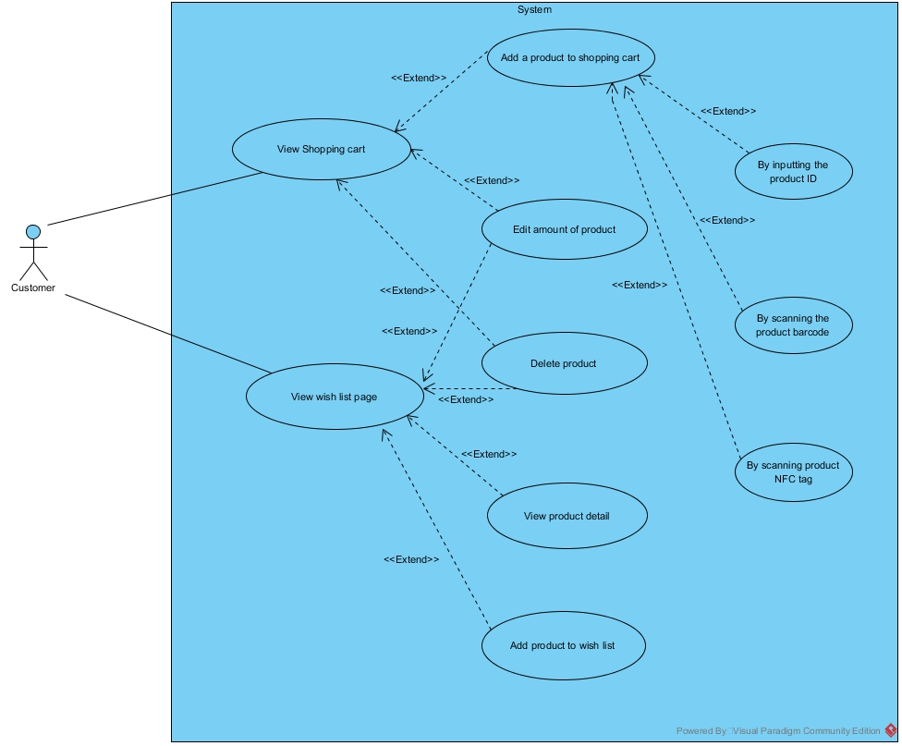

**Figure 15: Use Case Diagram Android Application**

|  |  |
| --- | --- |
| Use Case ID: | UCA-01 |
| Use Case Name : | View shopping cart |
| Short Description : | The customer can see the list of product in the shopping cart. |
| Actor: | Customer. |
| Pre-Conditions: | Launch the application |
| Post-Conditions: | Add / Edit / Delete the product |
| Flow Of Events: | 1. The customer select "Shopping Cart" from a menu bar. 2. The system receives the product list from the local storage. 3. The system calculates the total price of all product. 4. The system displays shopping cart to the customer. |
| Alternative Flow: | - |
| Exception: | - |
| Priority: | Medium |

## C:\Users\Wayne\Downloads\Project\Pic\View Shop.jpg

**Figure 16: ADA-01 View**

|  |  |
| --- | --- |
| Use Case ID: | UCA-02 |
| Use Case Name : | Add product to shopping cart. |
| Short Description : | The customer can add a product to the shopping cart of application for doing next process. |
| Actor: | Customer. |
| Pre-Conditions: | The supermarket must provide the product detail in the database. |
| Post-Conditions: | The product shows on the shopping cart list. |
| Flow Of Events: | 1. The customer select "Shopping Cart" from the menu bar. 2. The customer select Add button. 3. The customer select "Input ID". 4. The customer input the product id of the product that they want to add. 5. The system connects to the database and receives the product details. 6. The system is asking an amount of the product that customer want. 7. The system saves the product to the local storage. 8. The system reloads the page. |
| Alternative Flow: | From 3rd flow, customer can select "Barcode" for adding a product to the cart by scanning barcode  4. The system open camera feature.  5. The customer takes a picture on product barcode.  6. The system connects to the database and receive the product details.  7. The system save the product into the local storage.  8. Reload the page.  From 3rd flow, customer can select "NFC" for adding product to the cart by scanning NFC tag.  4. The system open camera feature.  5. The customer brings the smartphone near on product NFC tag.  6. The system connects to the database and receives the product details.  7. The system saves the product to the local storage.  8. The system reloads the page. |
| Exception: | - |
| Priority: | Medium |

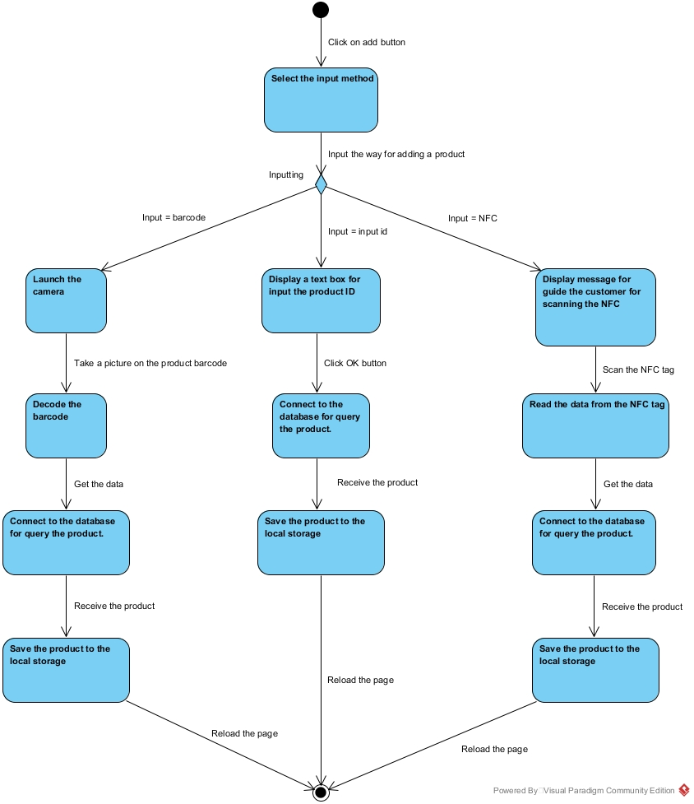

**Figure 17: ADA-02 Add Product in Shopping Cart**

|  |  |
| --- | --- |
| Use Case ID: | UCA-03 |
| Use Case Name : | Edit amount of product. |
| Short Description : | Customer can edit the amount of product. |
| Actor: | Customer. |
| Pre-Conditions: | The customer has to add some product before. |
| Post-Conditions: | The system will reload the page. |
| Flow Of Events: | 1. The customer selects text box that showing the amount of product. 2. The system pop up a virtual numerical keyboard on the screen. 3. The customer input amount of product. 4. The system asks the confirmation. 5. The customer select “Yes”. 6. The system reload the page. |
| Alternative Flow: | From 5th flow, If the customer selects "No" button. The system will reload the page. |
| Exception: | - |
| Priority: | Medium |

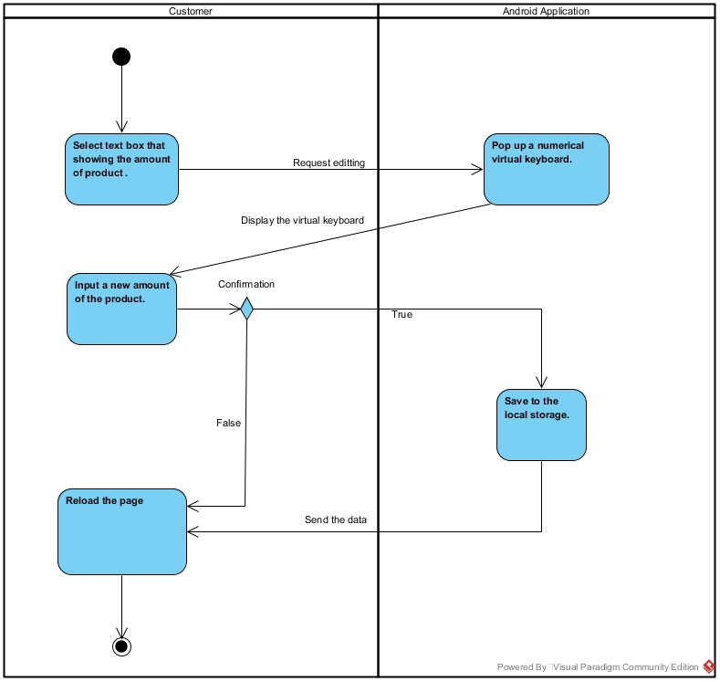

**Figure 18: AD-03 Edit Amount of Product**

|  |  |
| --- | --- |
| Use Case ID: | UCA-04 |
| Use Case Name : | Delete the product. |
| Short Description : | The customer can delete the product from the list. |
| Actor: | Customer. |
| Pre-Conditions: | The customer has to add some product before. |
| Post-Conditions: | The system will reload the page. |
| Flow Of Events: | 1. The customer select delete button. 2. The system is asking confirmation to the customer. 3. The customer select "Yes" button. 4. The system deletes the product from the local storage. 5. The system reloads the page. |
| Alternative Flow: | From 4th flow, If the customer selects "No" button.  4. The customer select "No" button.  5. The system reloads the page. |
| Exception: | - |
| Priority: | Medium |

## C:\Users\Wayne\Downloads\Project\Pic\Delete.jpg

**Figure 19: ADA-04 Delete Product**

|  |  |
| --- | --- |
| Use Case ID: | UCA-05 |
| Use Case Name : | View wish list |
| Short Description : | The customer can see the list of product that added by the customer on the wish list page. |
| Actor: | Customer. |
| Pre-Conditions: | Launch the application |
| Post-Conditions: | Add / Edit amount / Delete the product |
| Flow Of Events: | 1. The customer select "Wish list" from the menu bar. 2. The system load the save file in the local storage that contain the list of product. 3. The system calculates the total price of all product. 4. The system checks the products that already in the shopping cart. 5. The system highlights the check box of the product that already in the shopping cart. 6. The system displays the wish list page to the customer. |
| Alternative Flow: | From the 3rd flow. If there are no the same product, the system will display the wish list page to the customer. |
| Exception: | - |
| Priority: | Medium |

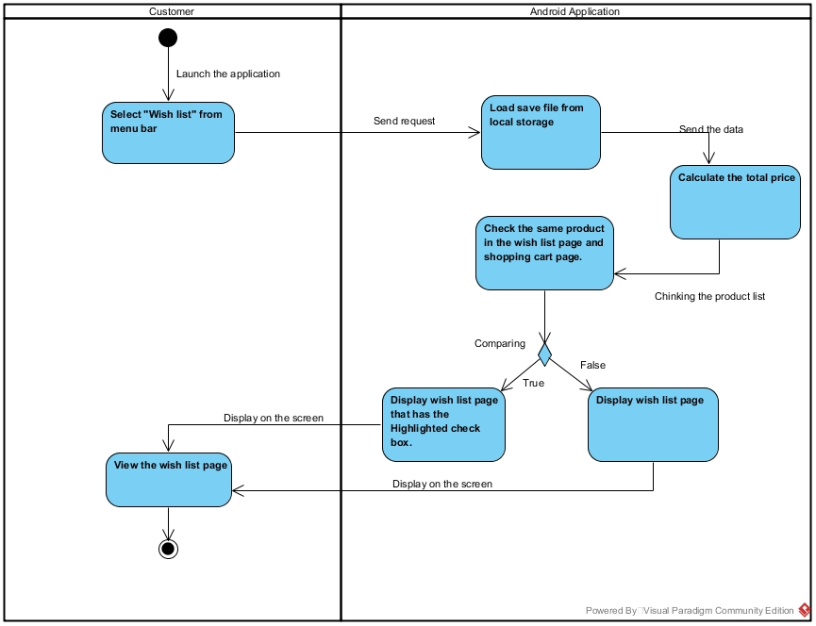

**Figure 20: ADA-05 View wish list.**

|  |  |
| --- | --- |
| Use Case ID: | UCA-06 |
| Use Case Name : | Add product to the wish list. |
| Short Description : | The customer can add a product to the wish list of application for doing next process by selecting the product list that query from the database. |
| Actor: | Customer. |
| Pre-Conditions: | The supermarket must provide the product detail in the database. |
| Post-Conditions: | The product shows on the wish list. |
| Flow Of Events: | 1. The customer select “Wish list “from the menu bar. 2. The customer select "Add" button. 3. The system connects to the database and receives the product details to the list. 4. The customer select the product that they want from the list. 5. The name and the details of the product that add by the customer show on the screen. 6. The system displays the new product on the screen. |
| Alternative Flow: | - |
| Exception: | - |
| Priority: | Medium |

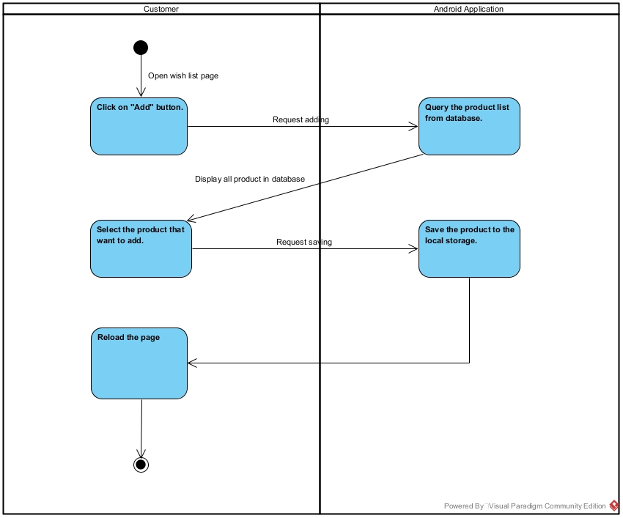

**Figure 21: ADA-06 Add product to the wish list.**

|  |  |
| --- | --- |
| Use Case ID: | UCA-07 |
| Use Case Name : | Check product detail. |
| Short Description : | The customer can view a product detail that contain the ID, name, description, categorize, net weight, price, the amount required for promotion and promotion of the product when the user click on the product. |
| Actor: | Customer. |
| Pre-Conditions: | The customer access to wish list page. |
| Post-Conditions: | The system shows the dialog that contain the product detail. |
| Flow Of Events: | 1. The custom clicks on add button. 2. The system connects to the database and receives the product details to the list. 3. The customer hold-clicks on the product. 4. The system shows a dialog that contain the detail of that product. |
| Alternative Flow: | - |
| Exception: | - |
| Priority: | Medium |

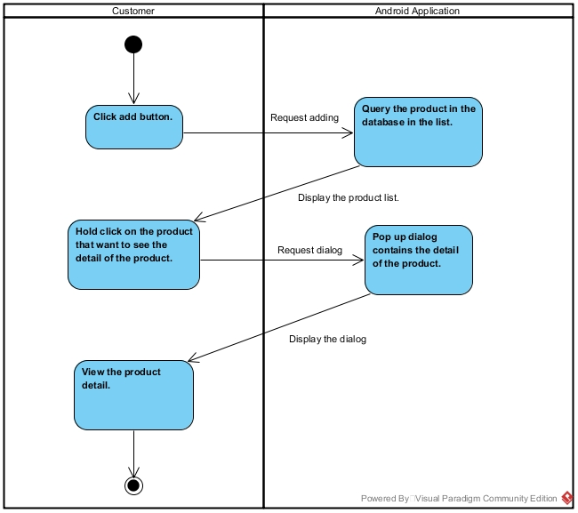

**Figure 22: ADA-07 Check product detail.**